TM
TECHNICAL PUBLICATIONS - An up thrust for knowledge

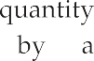
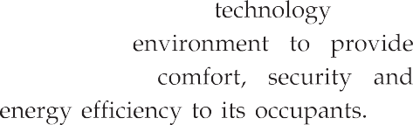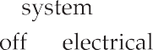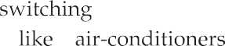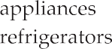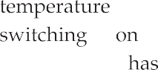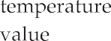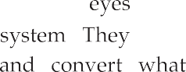
Purpose and requirement Specification for process model Specification for domain model Specification for information model Service specification
IoT level specification Functional view specification Operational view specification
Device and components integration

Application development
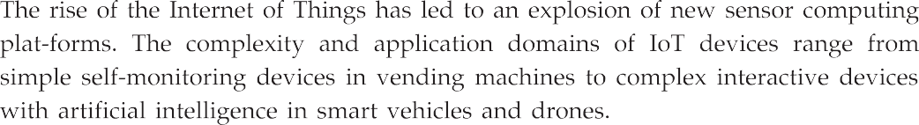
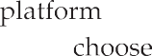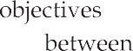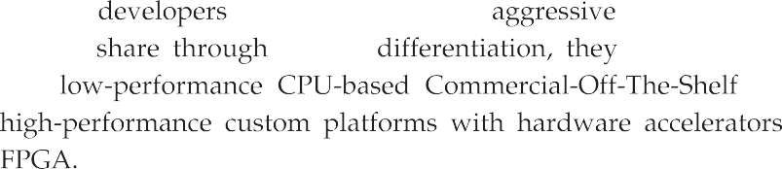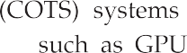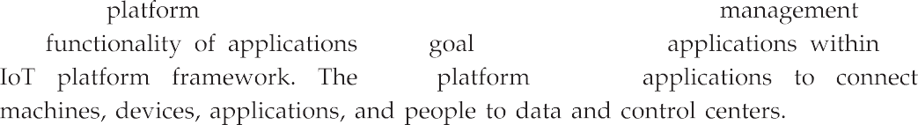

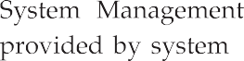
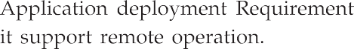
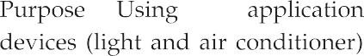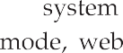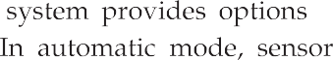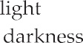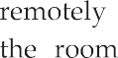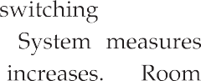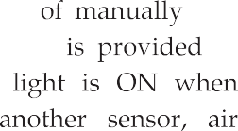

Start
Operating modes
Manual
Temp_state
Select mode
Auto
Temp_level
ON state
OFF state
ON state
OFF state

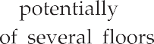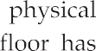
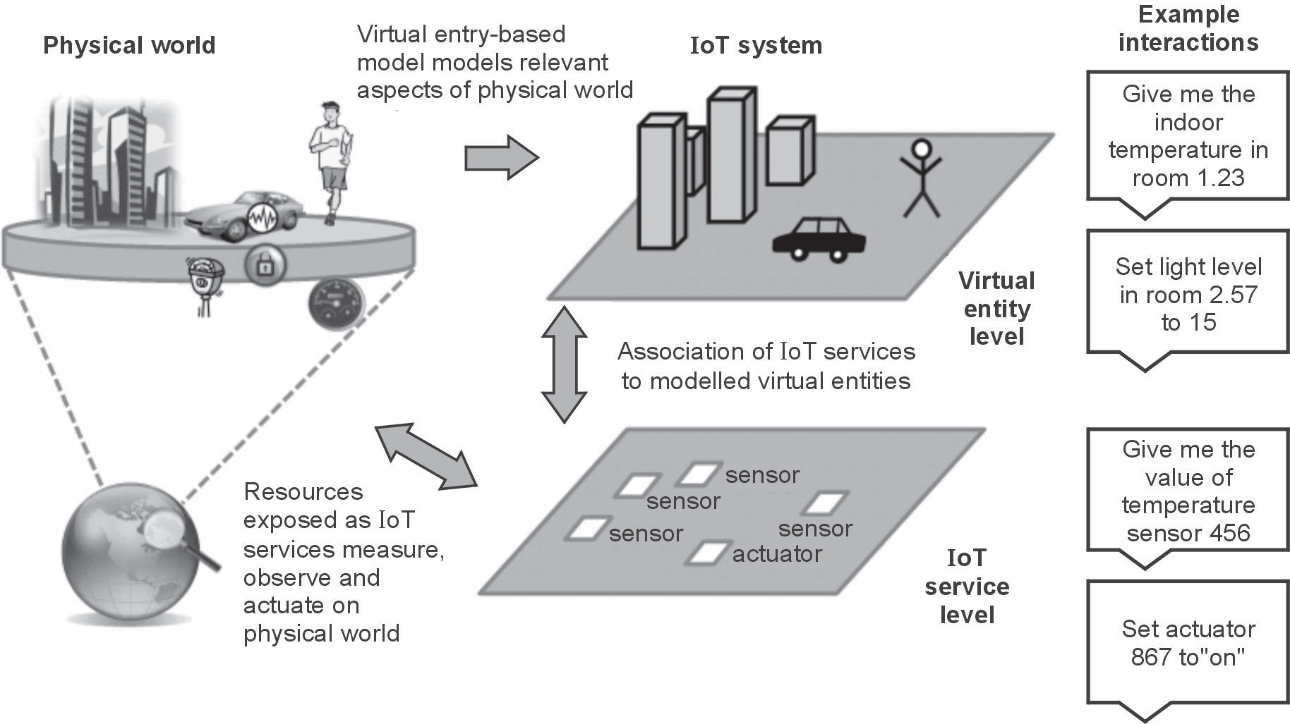
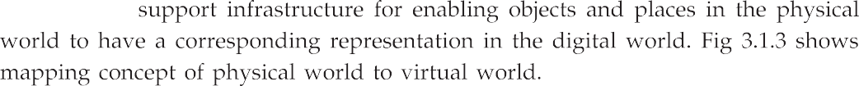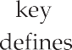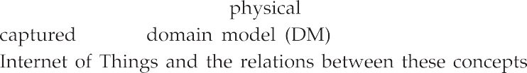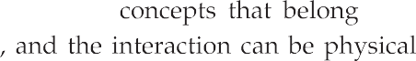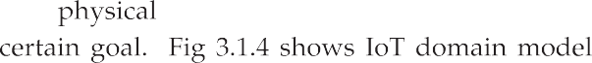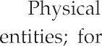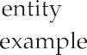

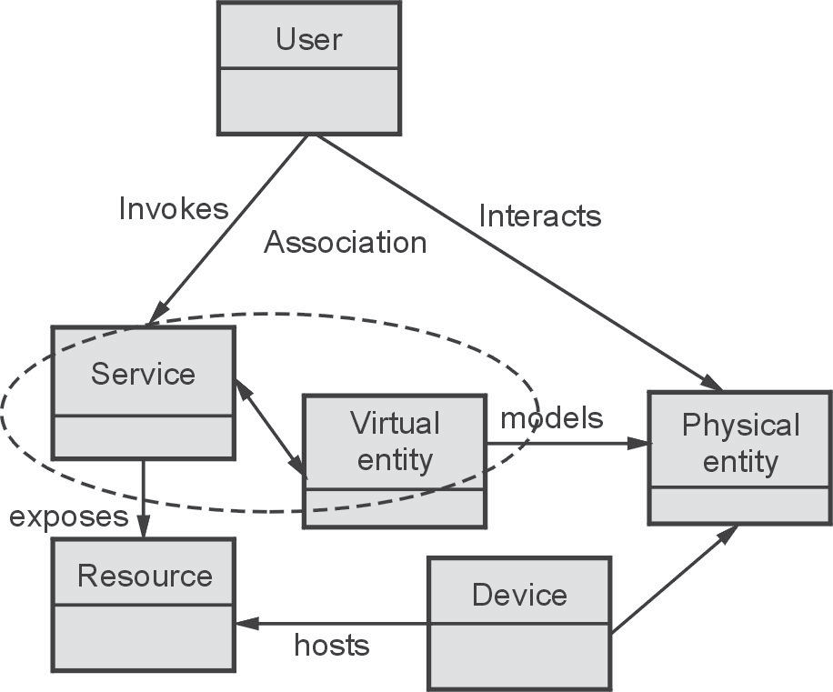
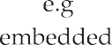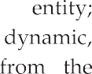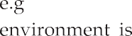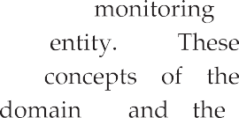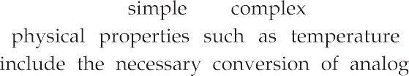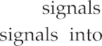
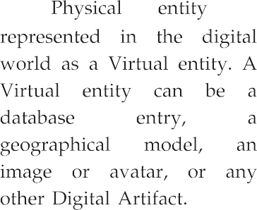

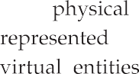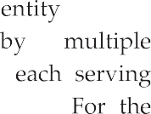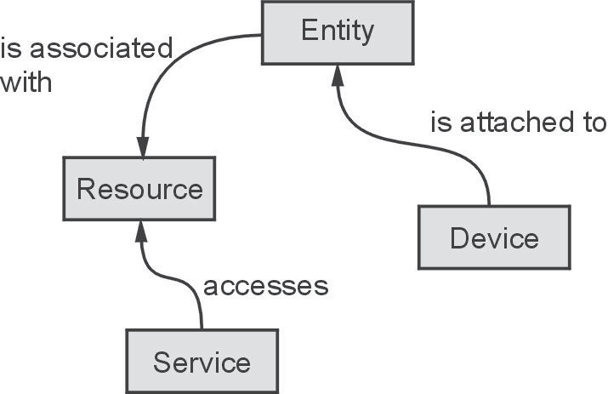

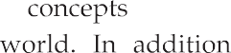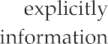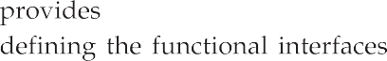

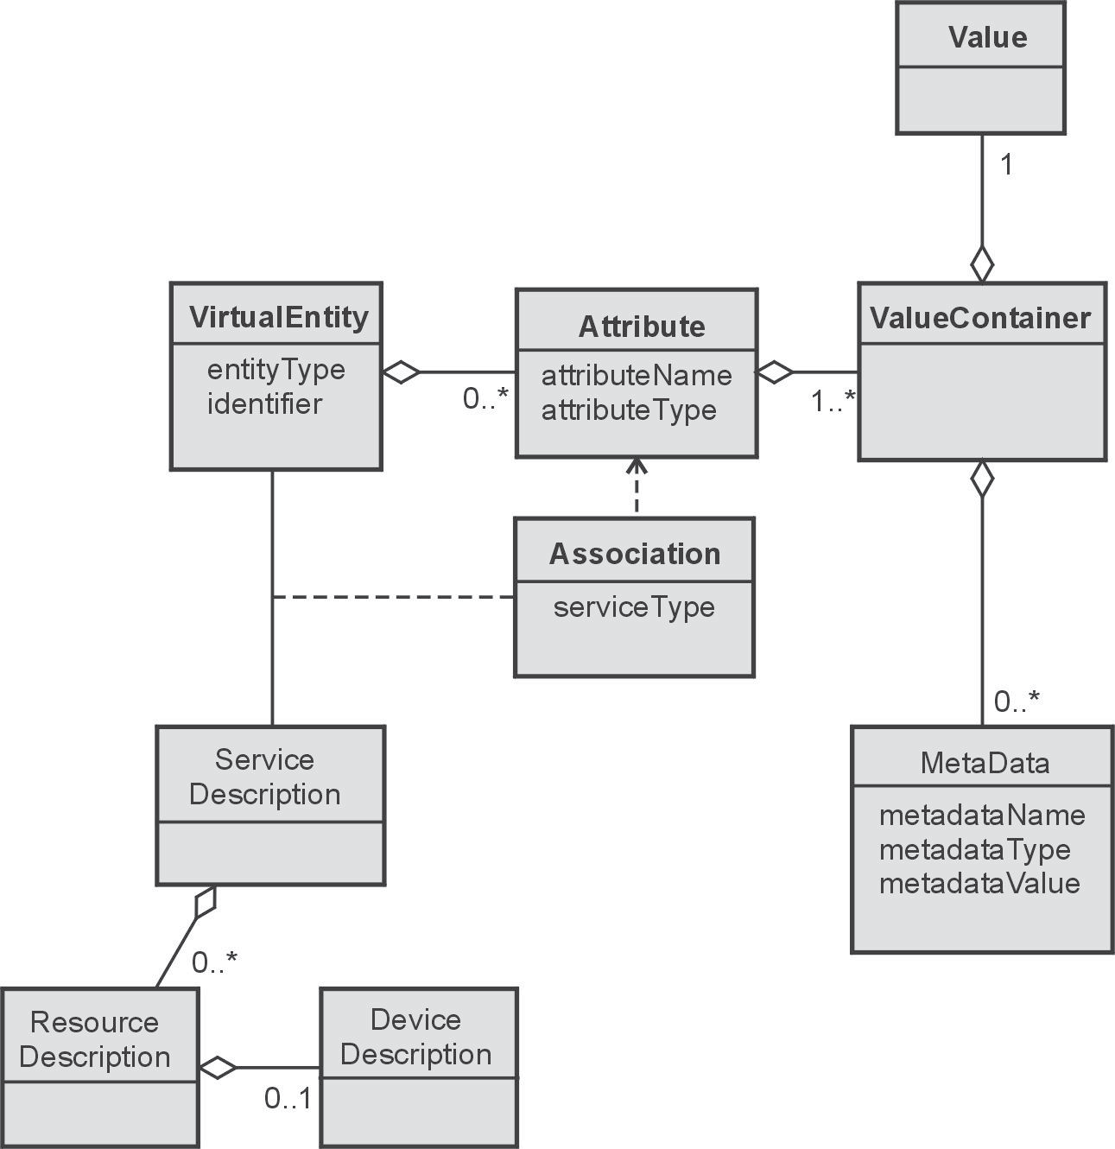

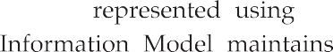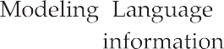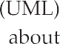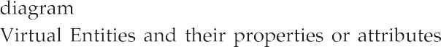
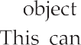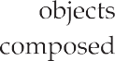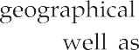

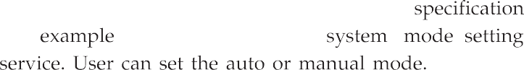

Input
Mode : Auto/Manual

Service
Name : Controller Type : Native

Output
State : ON/OFF

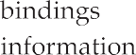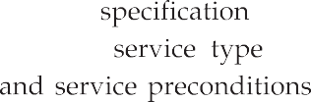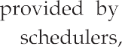

Schedule
Interval : Every 7 minutes

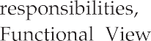
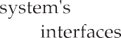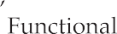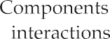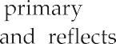

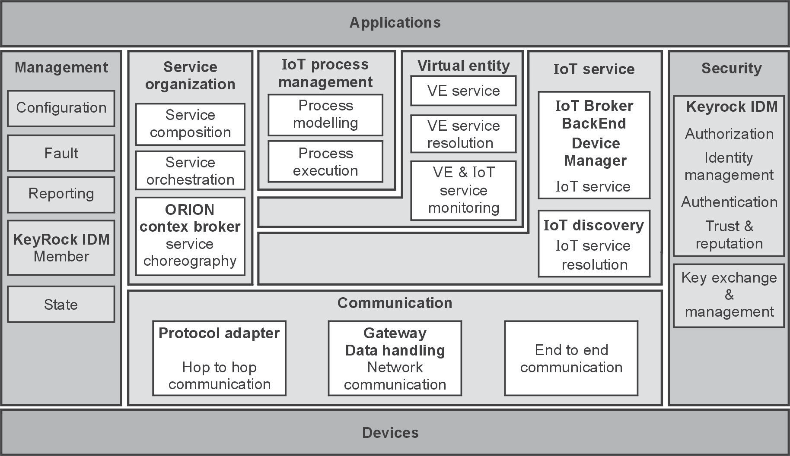
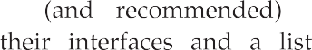

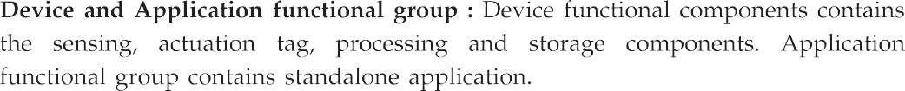
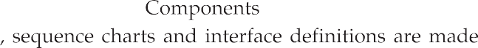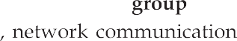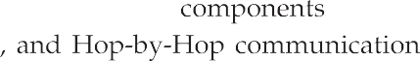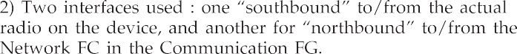

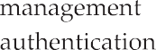

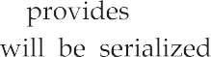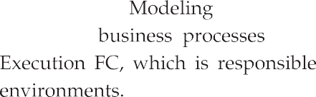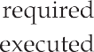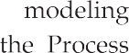
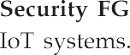
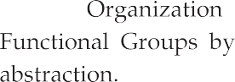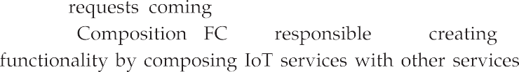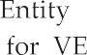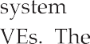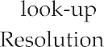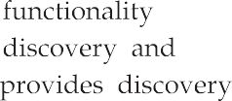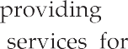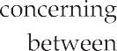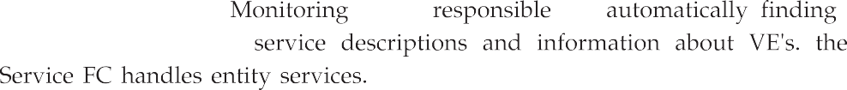

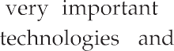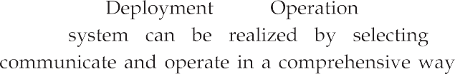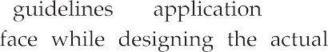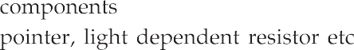

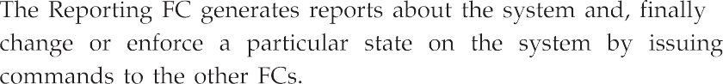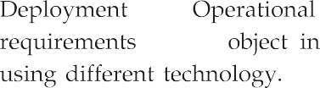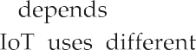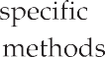

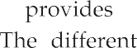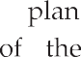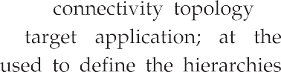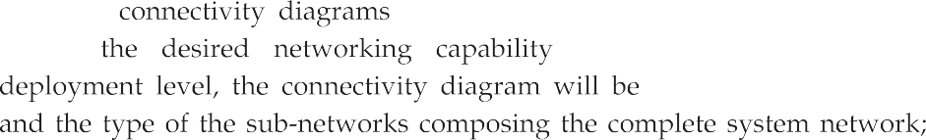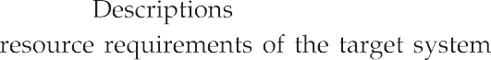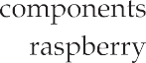

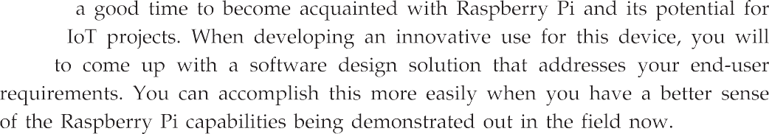

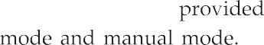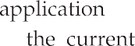
Controller
Light
Air conditioner
Auto mode
Manual mode
ON OFF
ON OFF

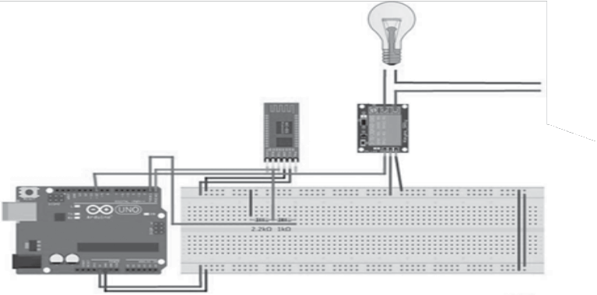
Power supply
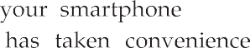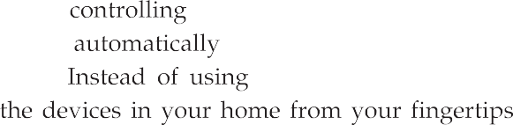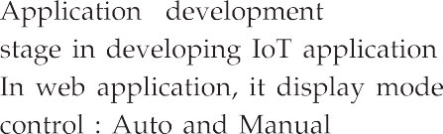

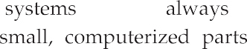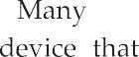
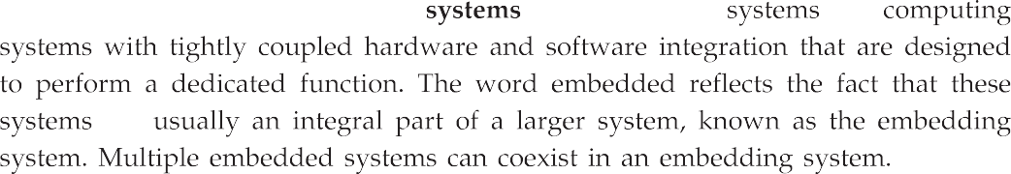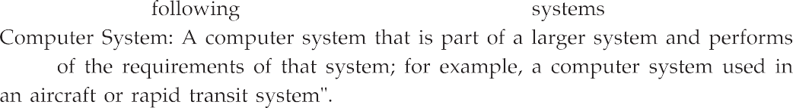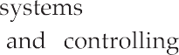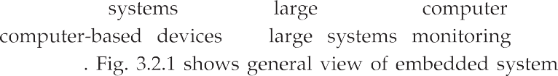

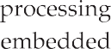
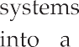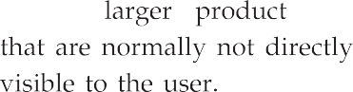 System inputs
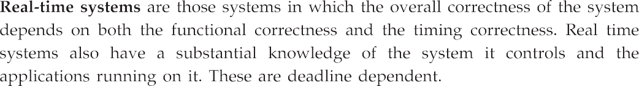
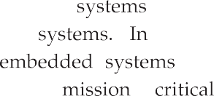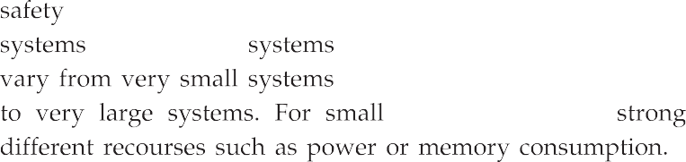
Embedded system
Software components
Hardware components
System outputs

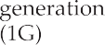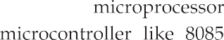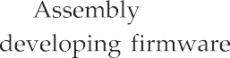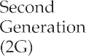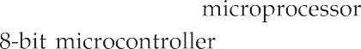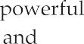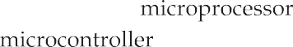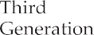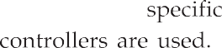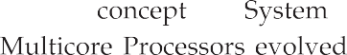

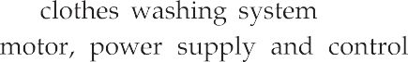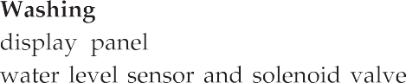

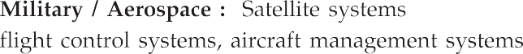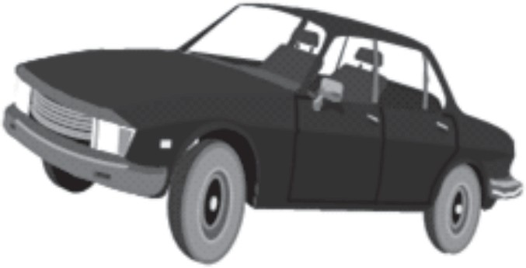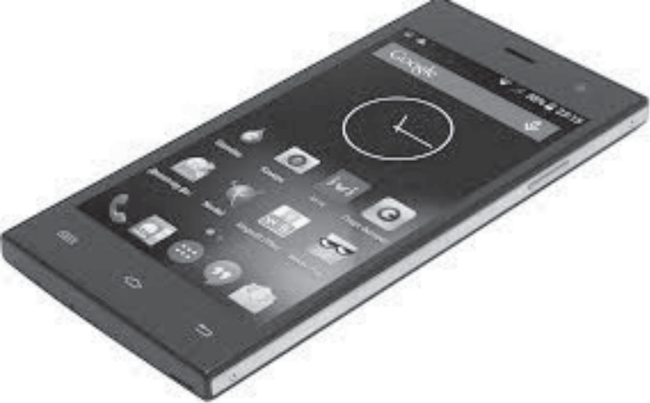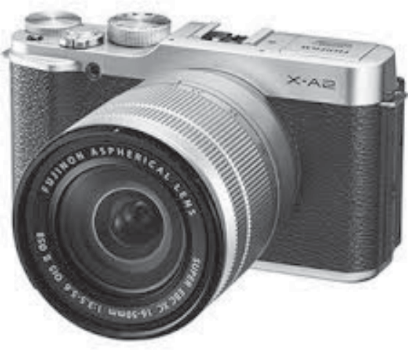

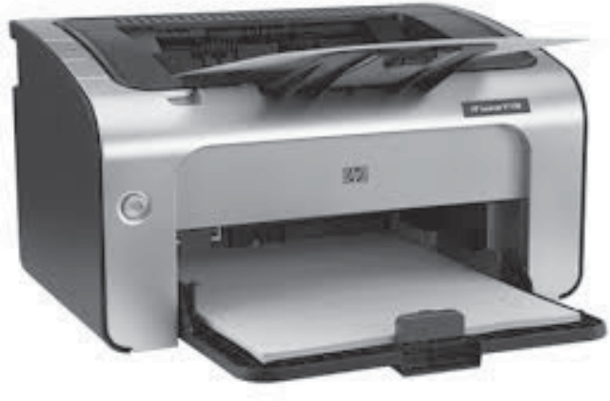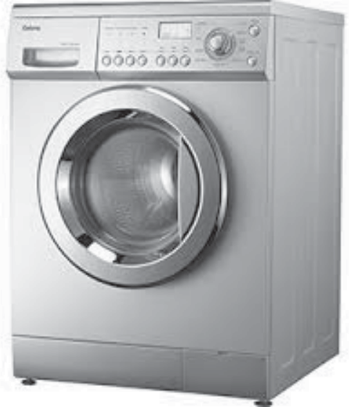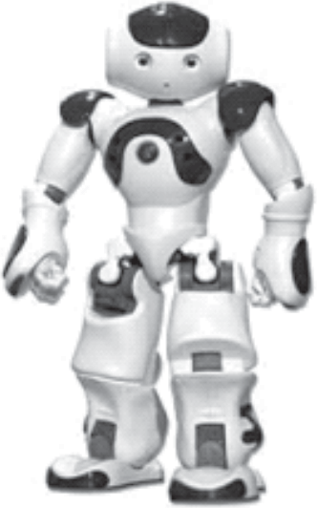
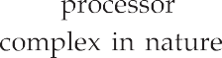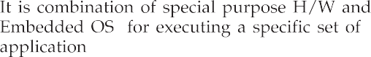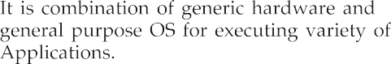

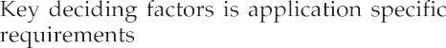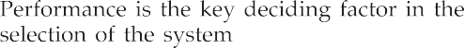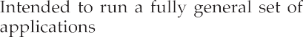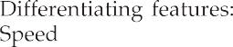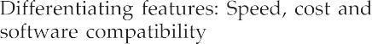
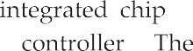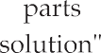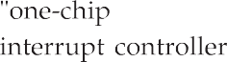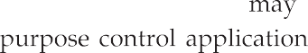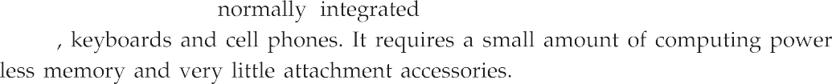

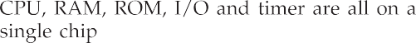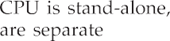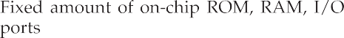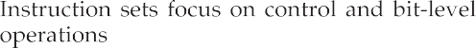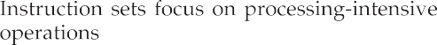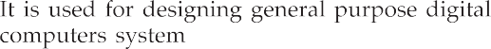
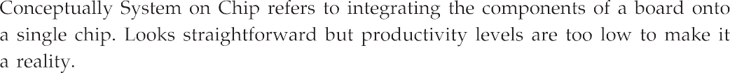
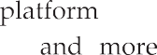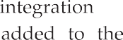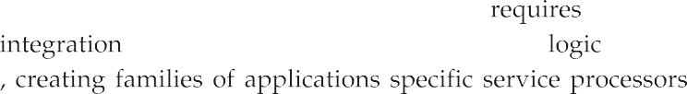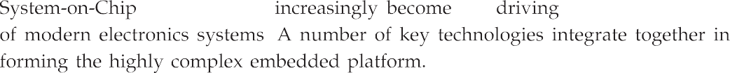

RISC
DSP
RISC MAC
TAP/ TAM
Speech CODEC
DMA
Control
Flash
Modulator
SRAM
PCI Glue
Control logic
Temp. sensor
CMOS
camera
DA
AD

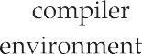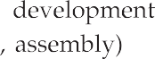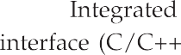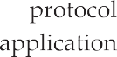

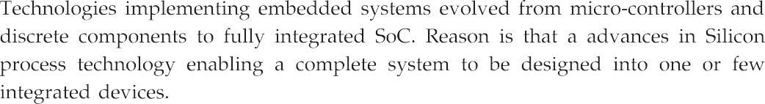
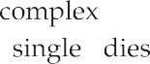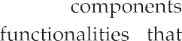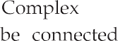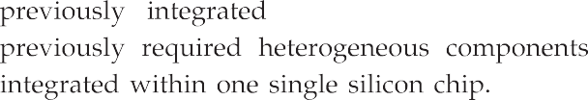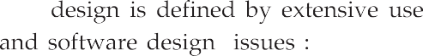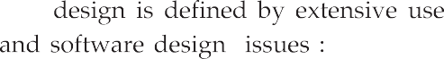

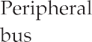
Memory
Embedded software API
MPU / CPU
Interface and peripherals
Configurable hardware
DSP
core
ASIC
ADC DAC
RF / IF subsystem

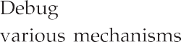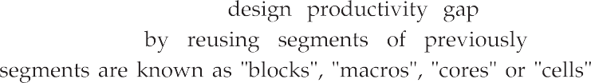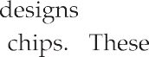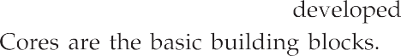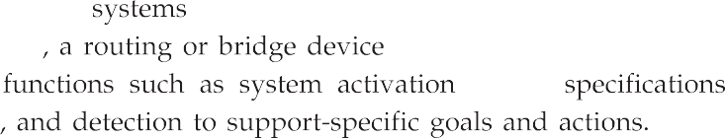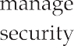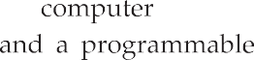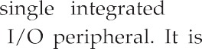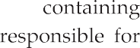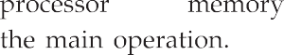

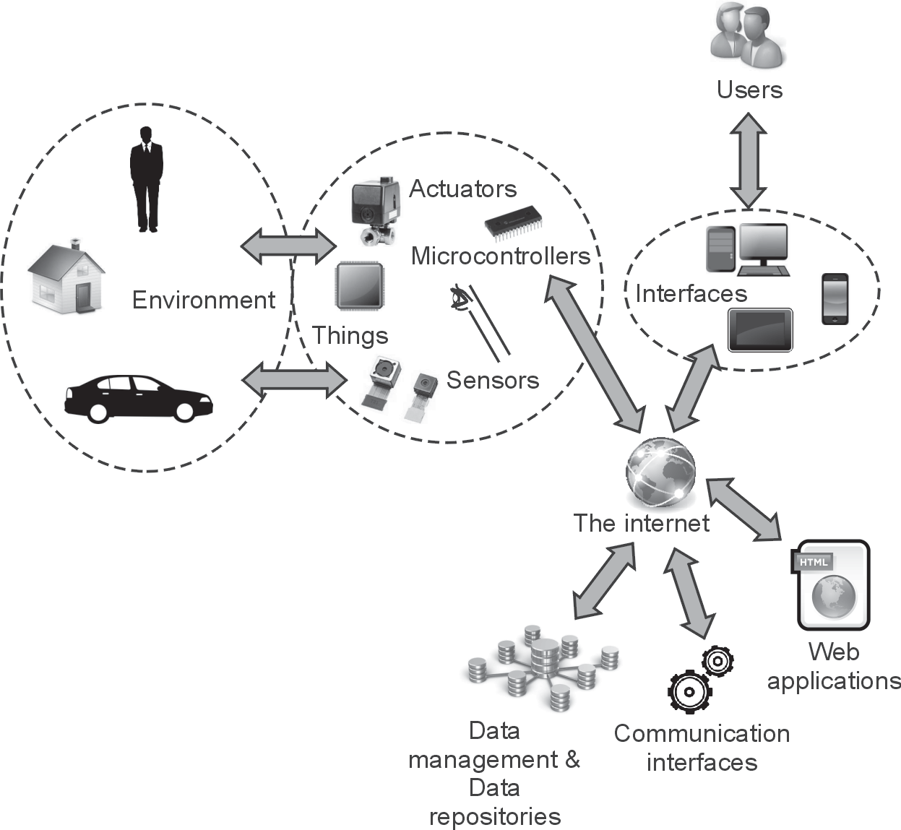

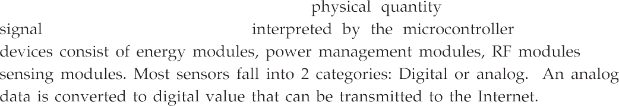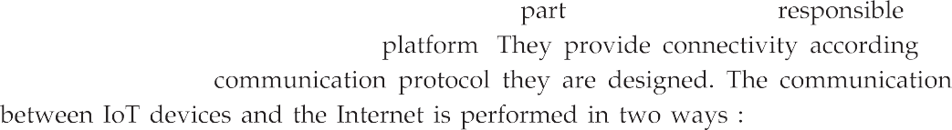

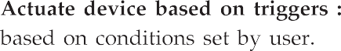
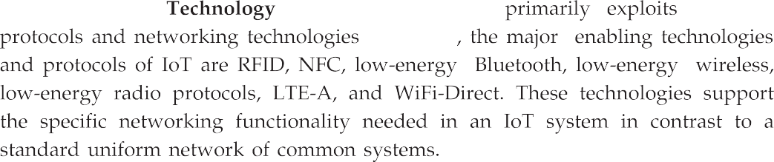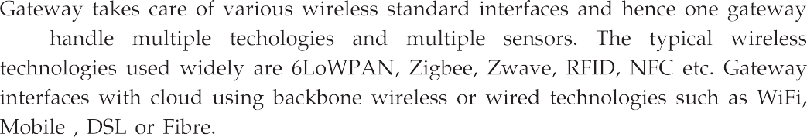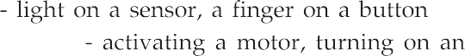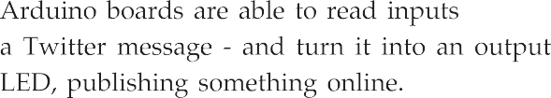

3 2
1 1
1 0
1 1
9 8
7 6 5 4 3 2 1 0
Digital
USB
Arduino
http://arduino.berlios.de

Q1
D1
ICSP
IC1
X'
Power
5V GND 9V
Analog in
0 1 2 3 4 5
SV1
AREF
GND
PWM1 PWM0
PWR
RX

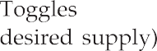

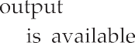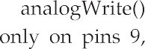
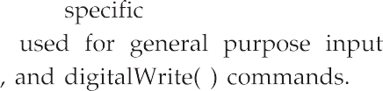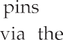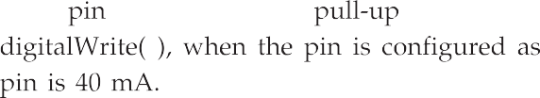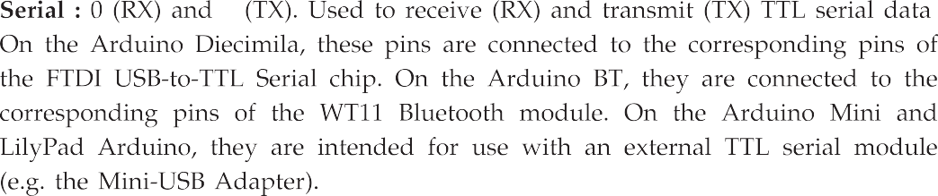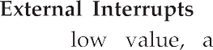

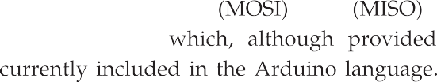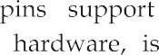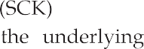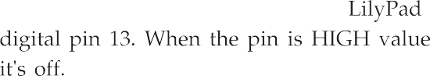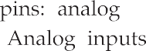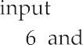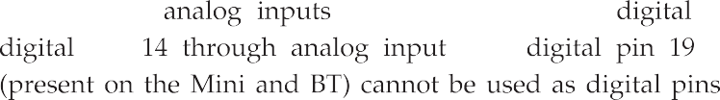

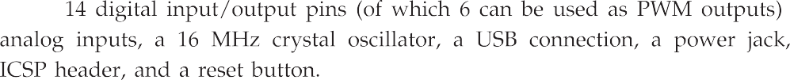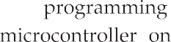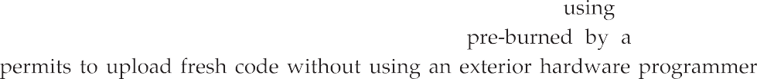
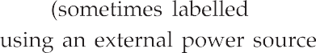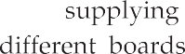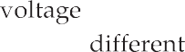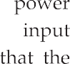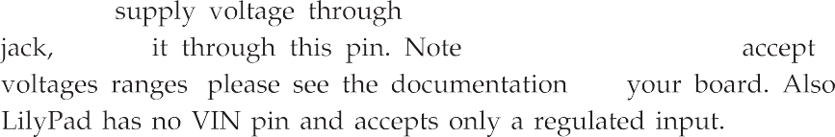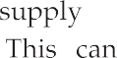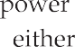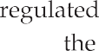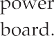

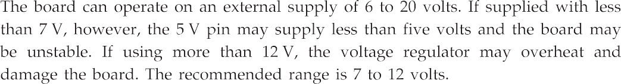

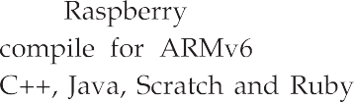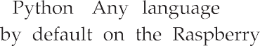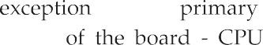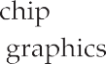
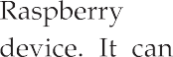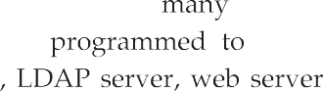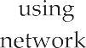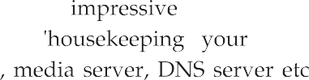

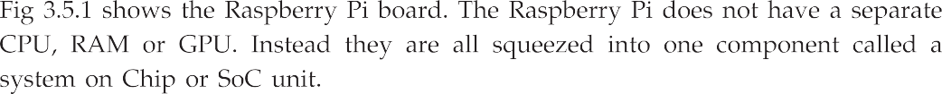
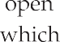
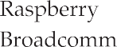

GPIO
headers

RCA VIDEO OUT
JTAG
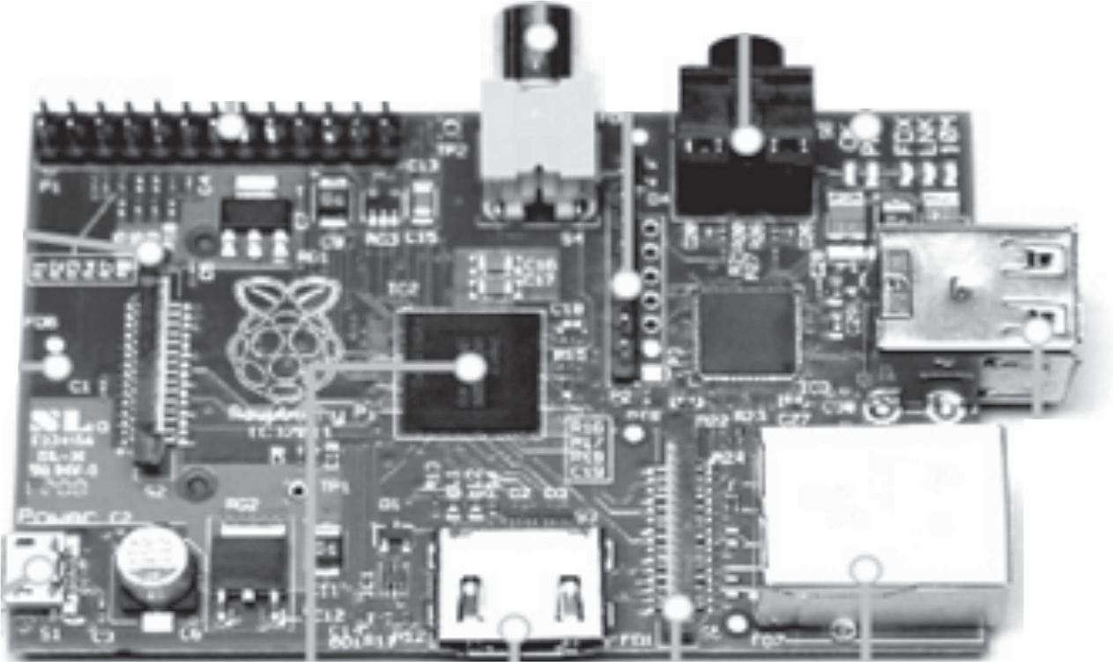headers

AUDIO OUT

Status LEDs

DSI display connector

SD card slot (back of board)

USB 2.0

Micro USB power (5 V 1 A DC)

Broadcom BCM 2835
ARM11 700 MHz

HDMI OUT

ETHERNET OUT
only on 256 MB models

CSI connector camera

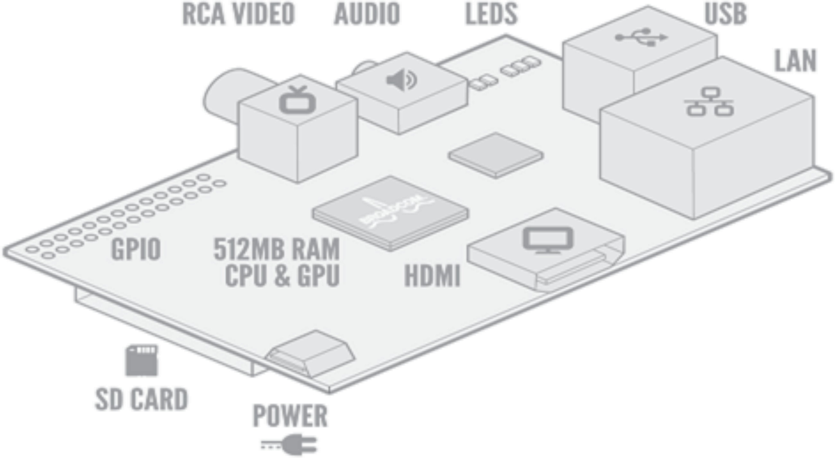
USB
LEDs
RCA video
Audio
LAN
GPIO
512 MB RAM
CPU and GPU
HDMI
SD card
Power

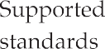
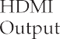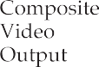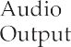

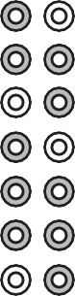
Raspberry Pi P1 header
PIN # Name Name PIN #
8
9
7
3.3 VDC power SDA0 (I2C)
SCL0 (I2C)
5.0 VDC power DNC
0 V (Ground)
0
GPIO 7
DNC GPIO 0
TxD
RxD GPIO1
15
16
1
- GPIO 2
- GPIO 3 DNC
DNC GPIO4 GPIO5 DNC GPIO6 CE0
CE1
4
5
- MOSI
- MISO
- SCLK
DNC
6
10
11
2 4
6
8 10 12 14 16 18 20 22 24 26
25 23 21 19 17 15 13 11 9
7
5
3
1
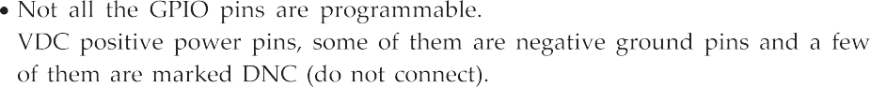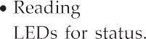
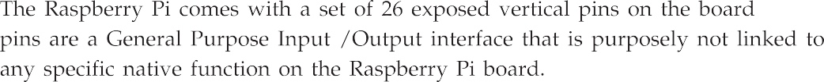

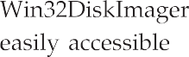
username
working directory

pi@raspberrypi ∼ $

hostname
type
after this

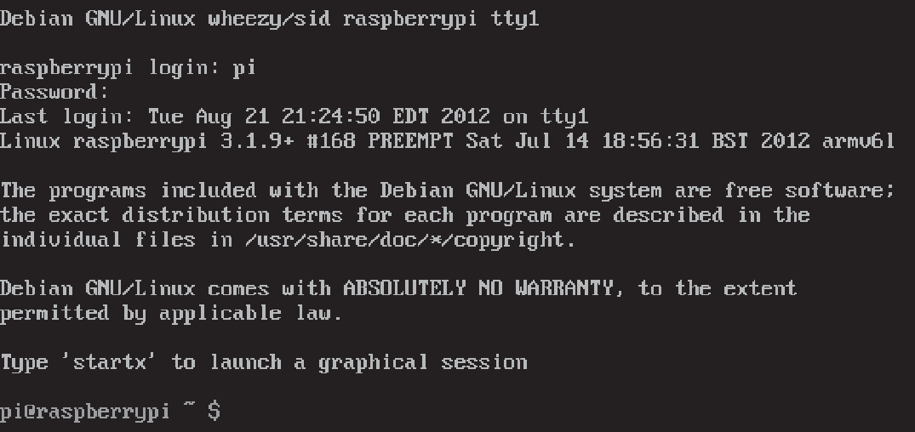
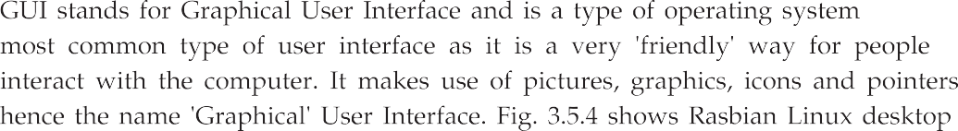

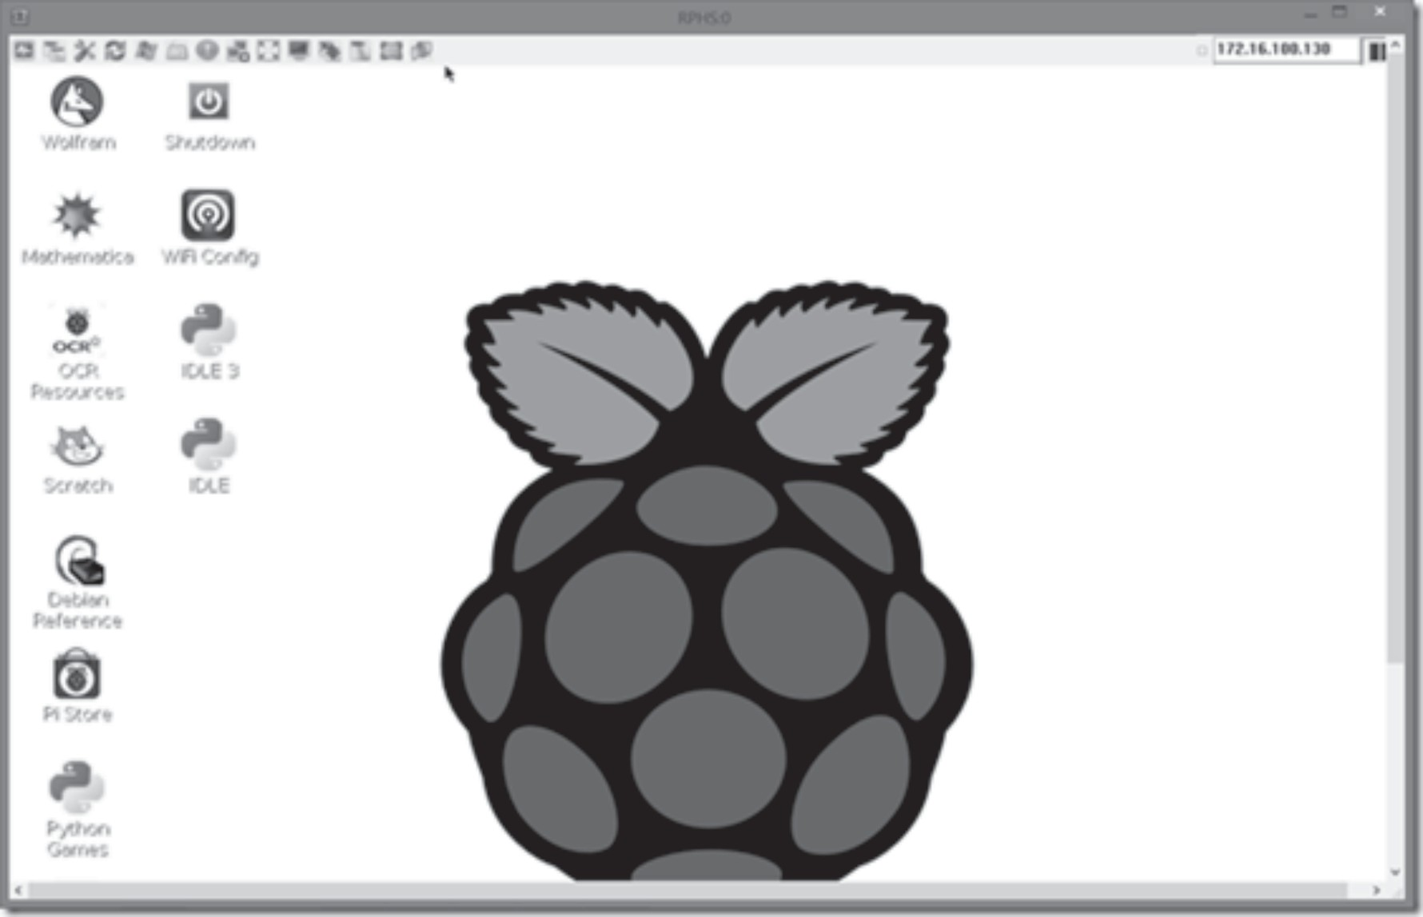
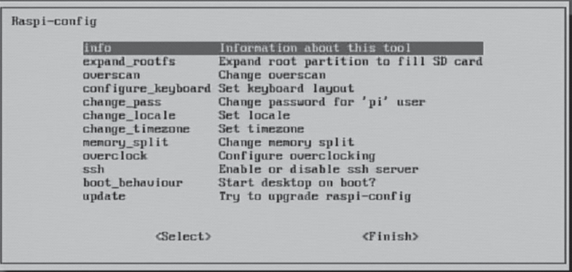

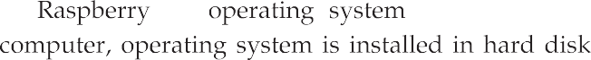

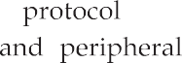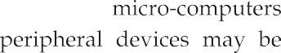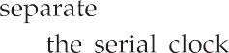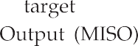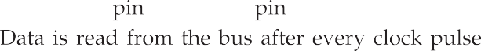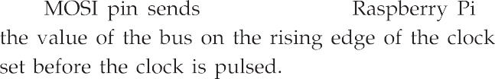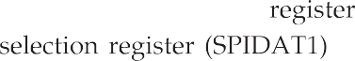

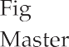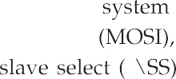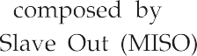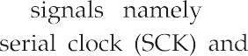

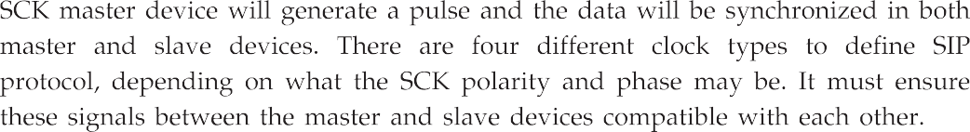
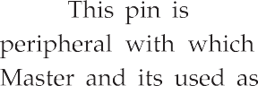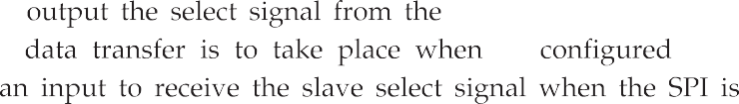
SCLK

MOSI
SPI Master
MISO
SPI Slave
SS

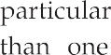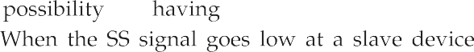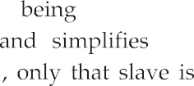
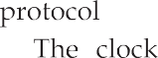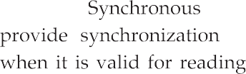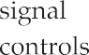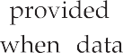
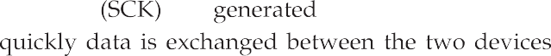

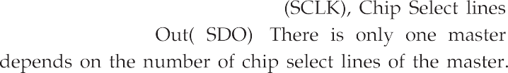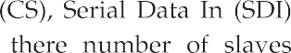
Master
Slave 1
Slave 2
MOSI MISO
Clock
SS
SS

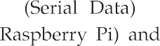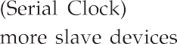
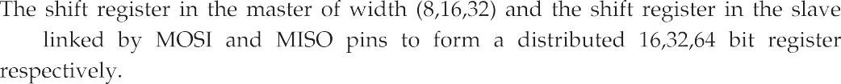
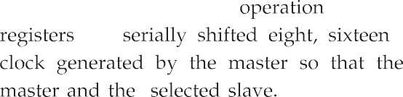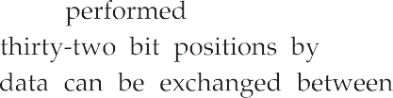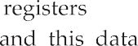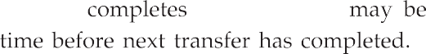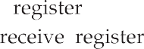

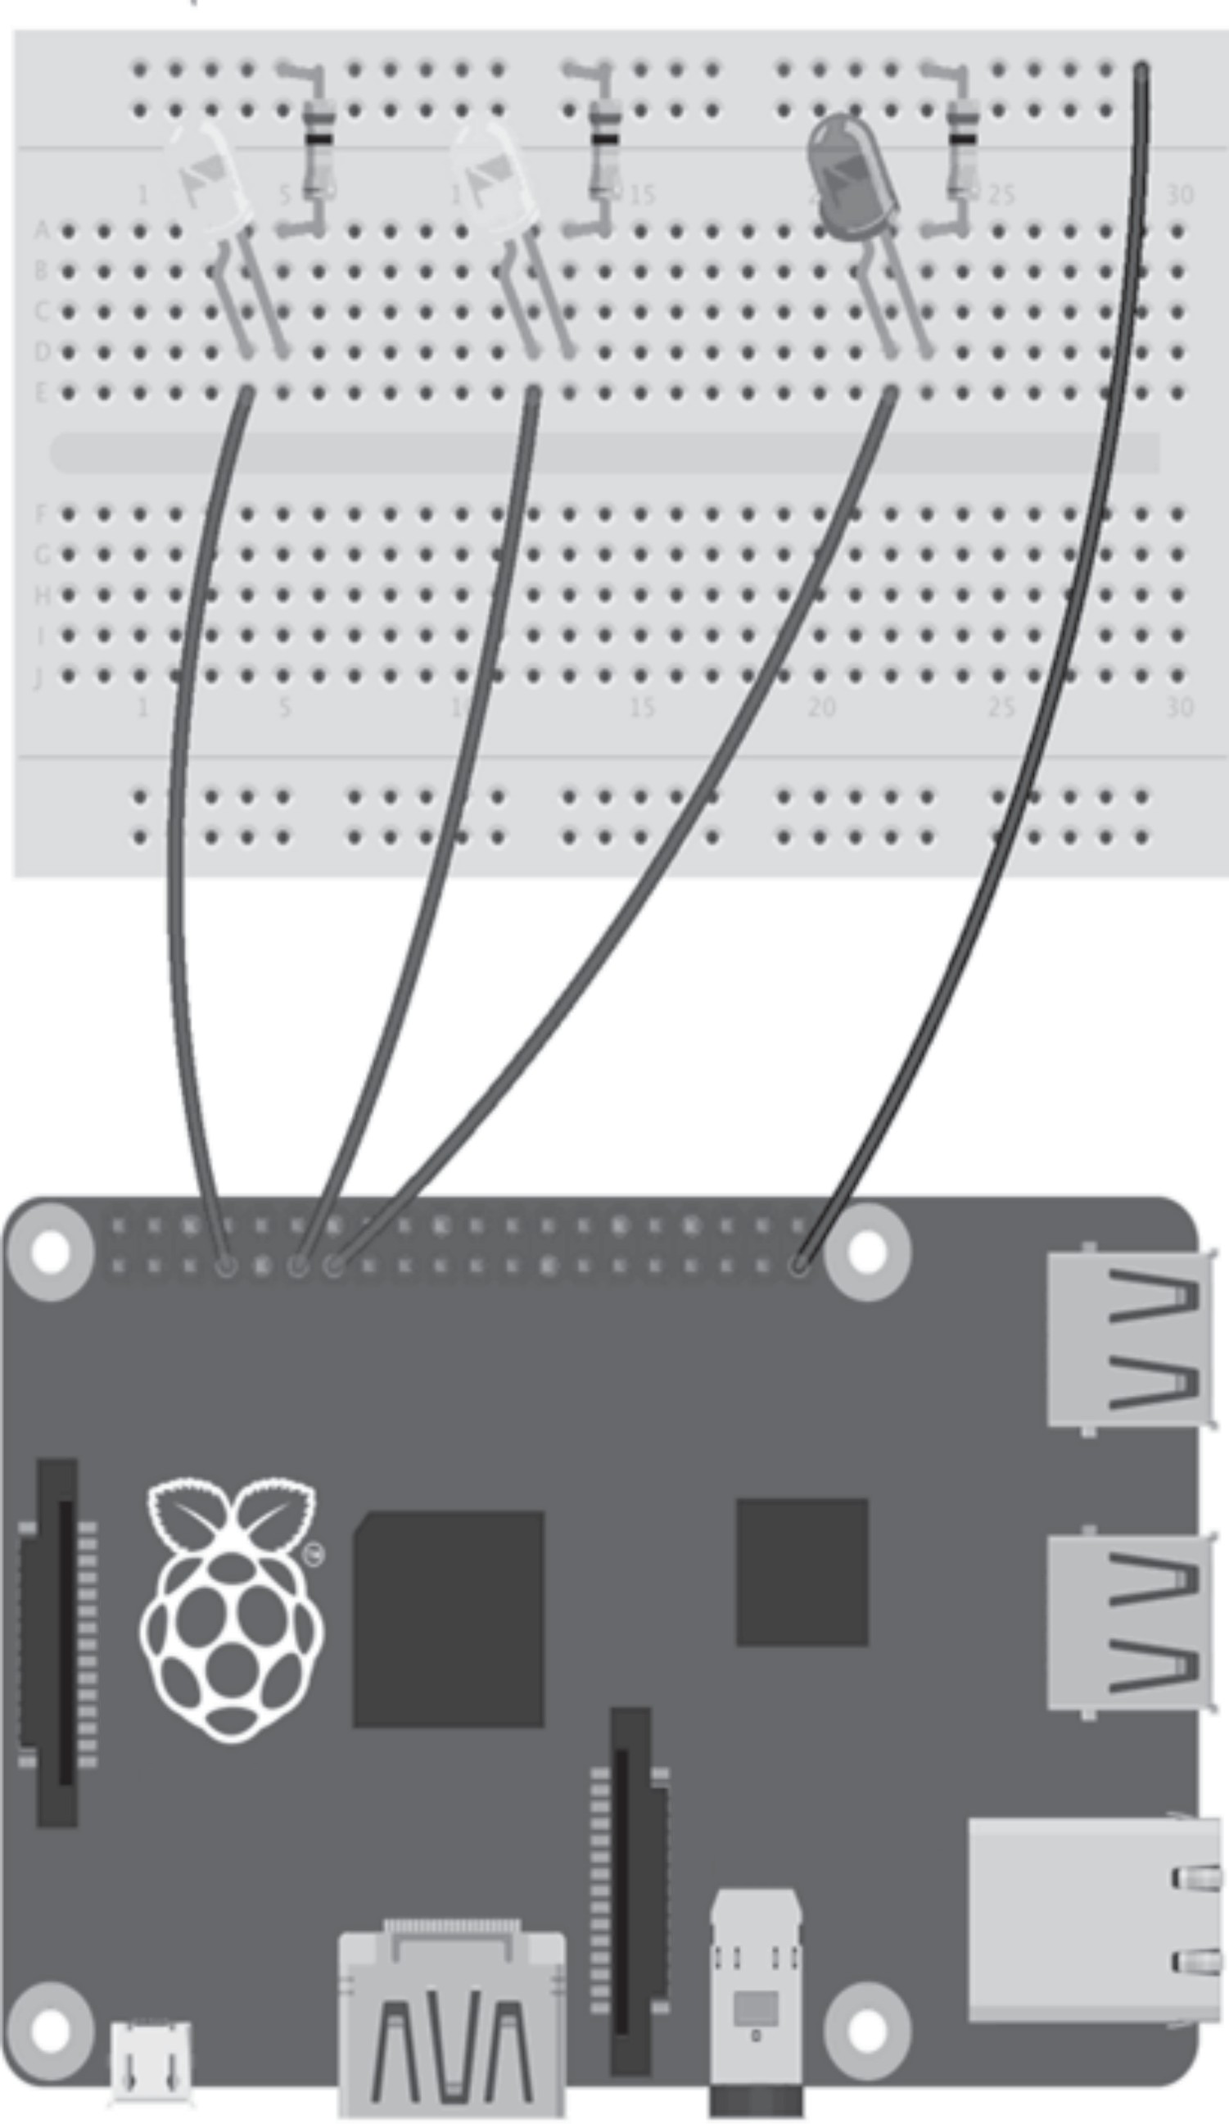
GPI0
Raspberry Pi Model 2 v1.1
© Raspberry Pi 2014
HDMI
Audio
Power
CSI (CAMERA)
GPIO 27
GPIO 17
GPIO 4
DSI (DISPLAY)
ETHERNET
USB 2x
USB 2x

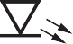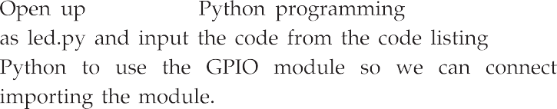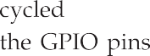
GPIO pin
I
VCC 3.3 V
Anode
200 Ω
200 Ω
Cathode
V
_+
R
GPIO pin
(a)
(b)
(c)

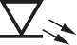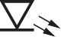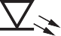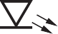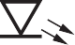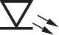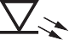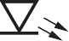
Pin 10 ... 6
A
Common anode
3,8
F
B
A
B
C
D
E
F
G
DP
E
G
D Pin 1 ... 5
C
DP
7
6
4
2
1
9
10
5

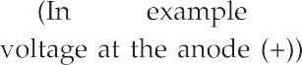

VCC 3.3 V

GPIO input pin
10 kΩ

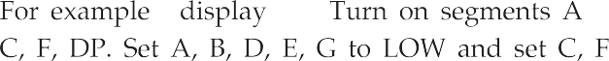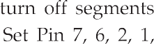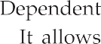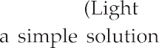

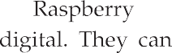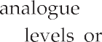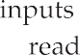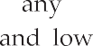pull up resistor

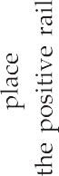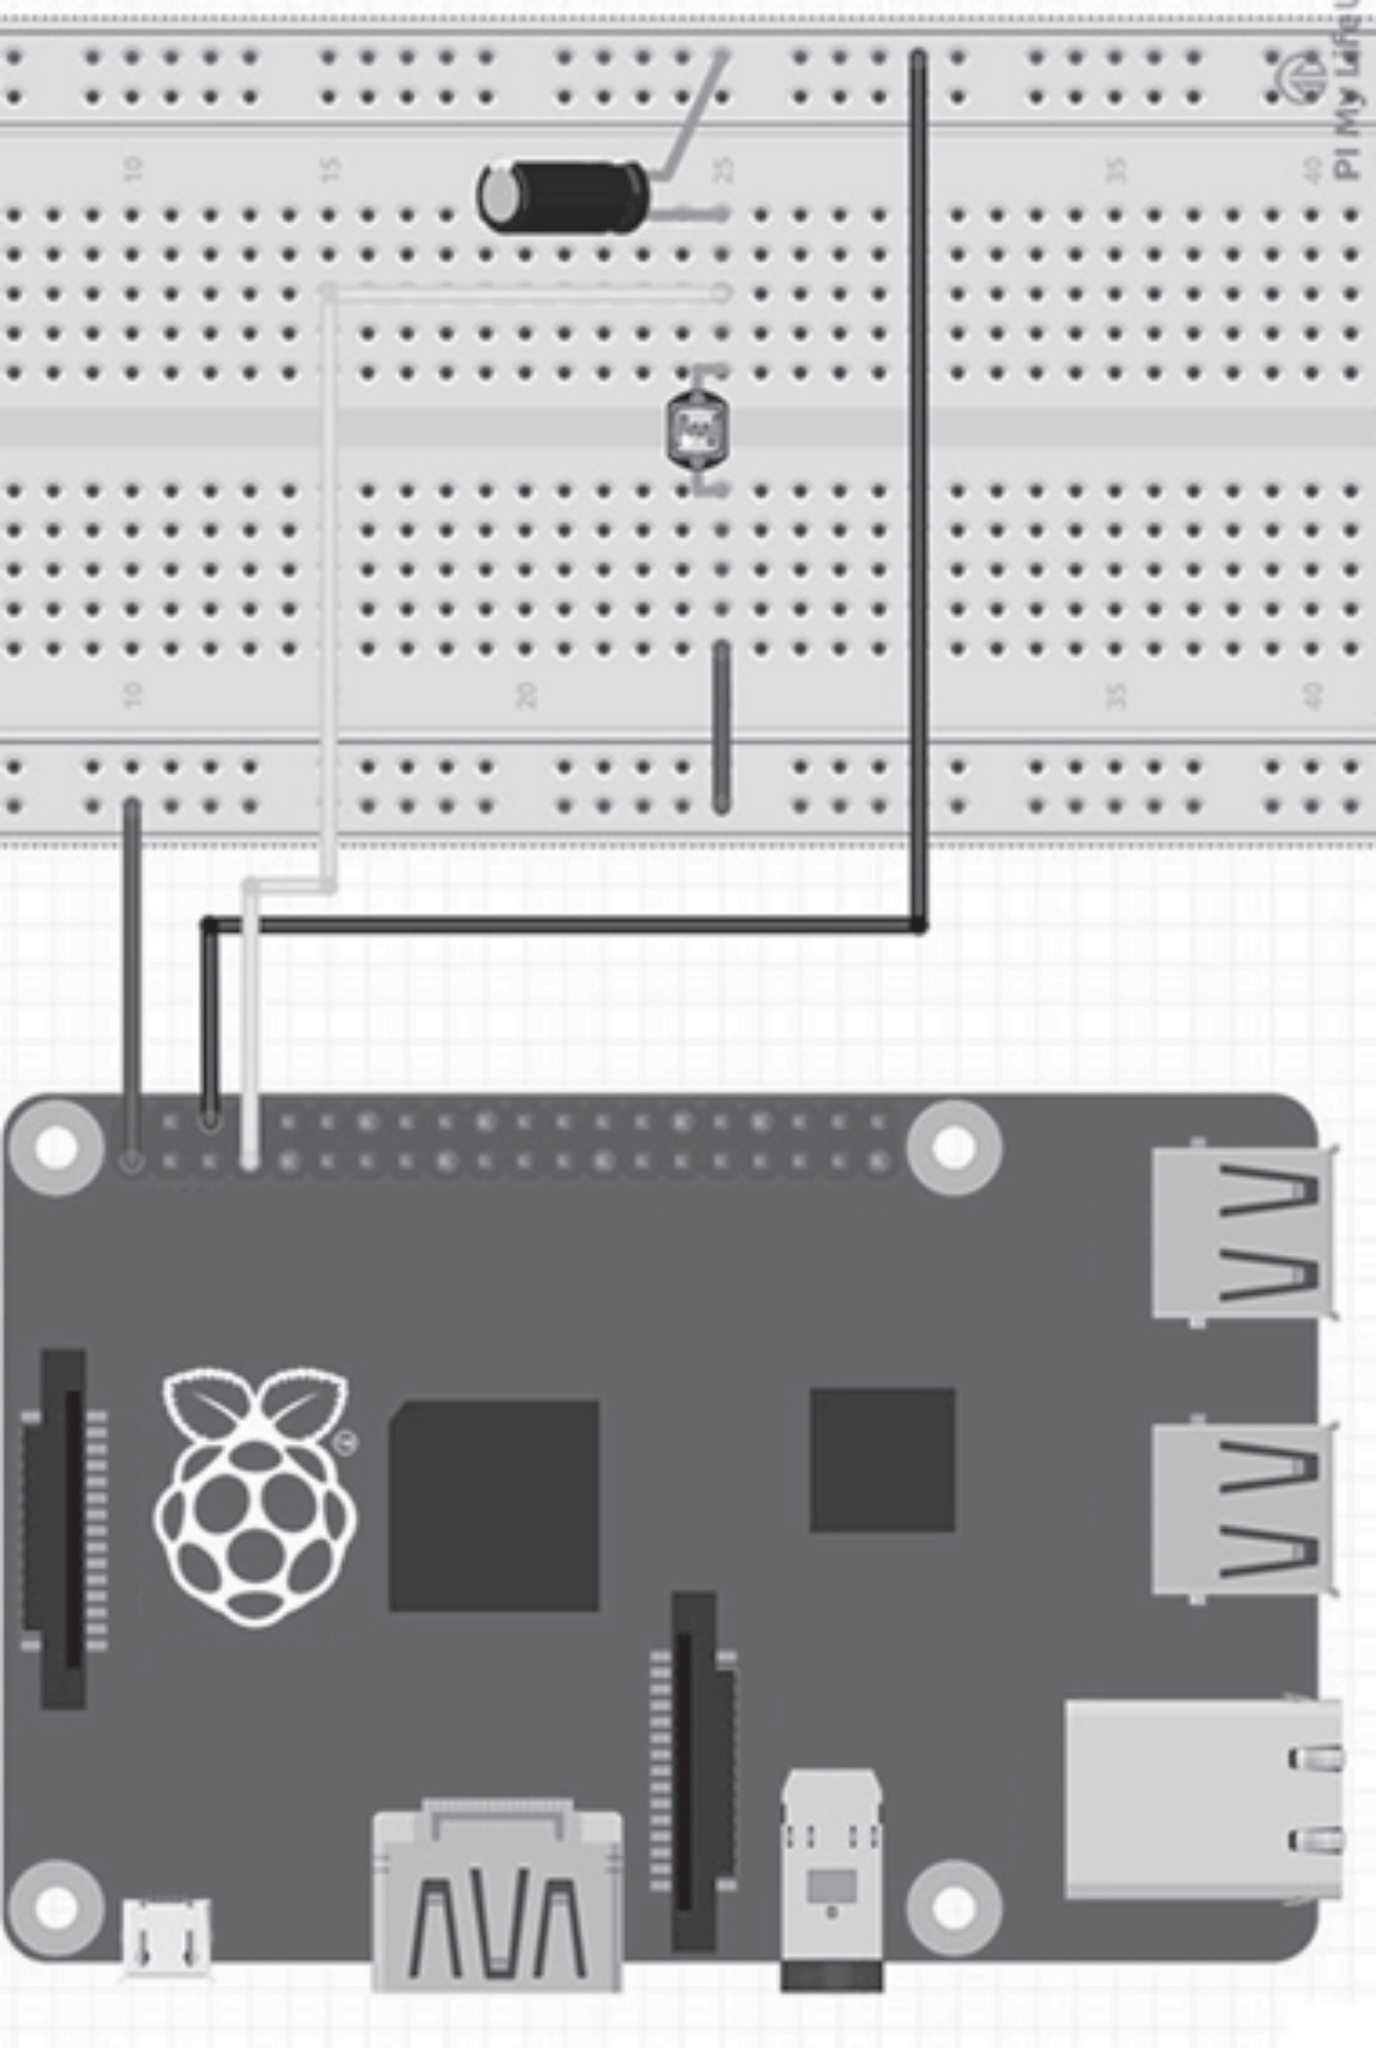
GPI0
Raspberry Pi Model 2 v1.1
© Raspberry Pi 2014
Audio
HDMI
Power
CSI (CAMERA)
DSI (DISPLAY)
ETHERNET
USB 2x
USB 2x

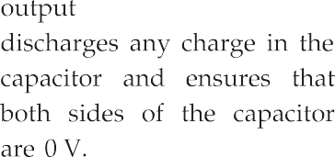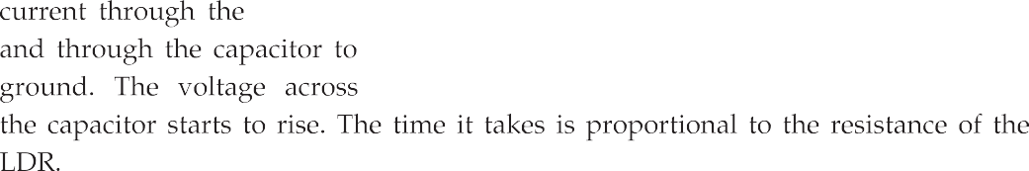
3.3 V (Pin 1)
R1
2.2 kΩ

LDR
GPIO
C1
1μF
GND (Pin 6)




